Low-Level Design (LLD)
Project Title: Setup and Configuration of Automated Testing and Release Process (CI)

- Detailed Infrastructured Design
  - Jenkins – Master Node:
  - Infrastructure: A Virtual Machine running on AWS
  - Endpoint:
      - User Access: http://<vm-external-ip>:8080
      - Inbound-Jenkins Connection: http://<vm-internal-ip>:50000 (TCP)
  - Jenkins Job:
        - Jenkinsfile: hosted in Git repository.
        - Call the Jenkins agent (node) – with a label.
        - Proceed with CI automation of deployment and testing suite in agent.
        - Collect a response from the agent upon successful run or failed run.
  - Considerations:
  - Packages needed: Docker.io.
        - Docker Image: jenkins/jenkins.
        - A service is needed to run Jenkins on machine startup
        - A persistent folder is needed to be mapped to jenkins_home
  - Jenkins – Agent Node:
- Infrastructure: A Virtual Machine running on AWS
- Endpoint:
- User Interface Access: http://<vm-external-ip>:8080
- Inbound-Jenkins Connection: http://<vm-internal-ip>:50000 (TCP)
- App Interface Access: http://<vm-external-ip>:8081
- Internal Testing Access: http://<vm-internal-ip>:8081
- Jenkins Job:
- Connect as an agent to the master via JNLP
- Using the Jenkinsfile for the next steps.
- Clone repository from GitHub to the agent
- Create a temporary Docker Image and add the temporary version as the GitHub Commit ID as a docker tag.
- Run the newly created docker image
- Run the Testing Suite.
    - Upon success – Add semantic version using docker tag to the temporary image and publish it to DockerHub.
    - Upon Failure – Print what failed and why.
  - Perform a cleanup by removing the temp image and cleaning up the workspace

- Considerations:
- Packages needed: Docker.io, Java.
- Docker Image: jenkins/jenkins
- A service is needed to run Jenkins on machine startup.

- Detailed Testing Suite Design
- Pytest: API test for each endpoint:
- Register (Liveness check):
- Endpoint: /register.
- Method: GET.
- Planned output: HTML.
- Testing Scenarios Examples: URL liveness check.
- Register (Create User):
- Endpoint: /register.
- Method: POST.
- Input: a valid user name, password and password confirmation.
- Structure: a JSON payload consists of fields:
{
"username" = "USERNAME"
"password" = "PASSWORD"
"password_confirmation" = "PASSWORD_CONFIRMATION"
}
- Planned output: OK code with a message, 400's code with a correct error message.
- Testing Scenarios Examples: valid payload, planned failure: (existing username, weak password, not matching passwords, empty fields, etc.).
- Login (Liveness check):
- Endpoint: /login.
- Method: GET.
- Planned output: HTML.
- Testing Scenarios: URL liveness check.
- Login:
- Endpoint: /login.
- Method: POST.
- Input: user name and password.
- Structure: a JSON payload consists of fields:
{
"username" = "USERNAME"
"password" = "PASSWORD"
}
- Planned output: OK code with a message, 400's code with a correct error message.
- Testing Scenarios Examples: valid payload, planned failure: (existings username, weak password, not matching passwords, empty fields, etc.).
- Dashboard:
- Endpoint: /dashboard.
- Method: GET.
- Planned output: user dashboard's HTML.
- Testing Scenarios Examples: URL liveness check, session check, correct table, username not in session.
- Logout (Liveness check):
- Endpoint: /logout.
- Method: GET.
- Planned output: login's HTML.
- Testing Scenarios Examples: URL liveness check, user removed from session, etc.
- Add Single Domains:
- Endpoint: /add_domain.
- Method: POST.
- Input: A single domain.
- Structure: a JSON payload consists of fields:
{
"domain" = "DOMAIN"
}
- Planned output: OK code with a message, 400's code with a correct error message.
- Testing Scenarios Examples: username not in session, valid payload, valid domain, domain exist, invalid domain, added domain to the <username>_domains.json file etc.
- Add Bulk Domains:
- Endpoint: /bulk_domains.
- Method: POST.
- Input: A file with a list of domains.
- Structure: a file payload consists of fields list of domains in each row.
- Planned output: OK code with summary, 400's code with a correct error message.
- Testing Scenarios Examples: valid payload, username not in session, file not existed, valid file type, added domains to the <username>_domains.json file, etc.
- Remove Domains:
- Endpoint: /remove_domains.
- Method: POST.
- Input: A list of domain in payload.
- Structure: a JSON payload consists of fields:
{
"DOMAIN1"
"DOMAIN2"
…
}
- Planned output: OK code, 400's code with a correct error message.
- Testing Scenarios Examples: username not in session, valid payload, valid domain, invalid domains' list, domains removed from the <username>_domains.json file, empty list, etc.
- Scan Domains:
- Endpoint: /scan_domains.
- Method: GET.
- Planned output: OK code with updated summary, 400's code and 500 code for failed scan with correct message.
- Testing Scenarios Examples: user in session, planned error, updated <username>_domain.json file, updated all domains, etc.
- Selenium (scenarios):
The following scenarios needs to be checked and ensured the correct operations of the application:
- Sign up (Register new user).
- Sign in (login existing user).
- Adding single domain and getting the correct result.
- Adding a bulk of domains using a file and getting the correct result.

- File Structure Design:
- Dockerfile Structure:
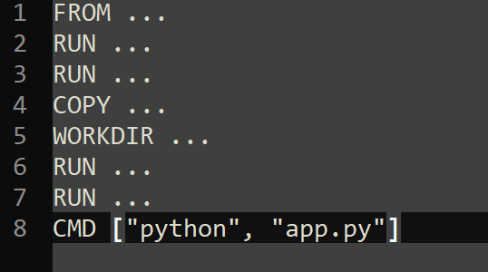
- Jenkinsfile Structure:
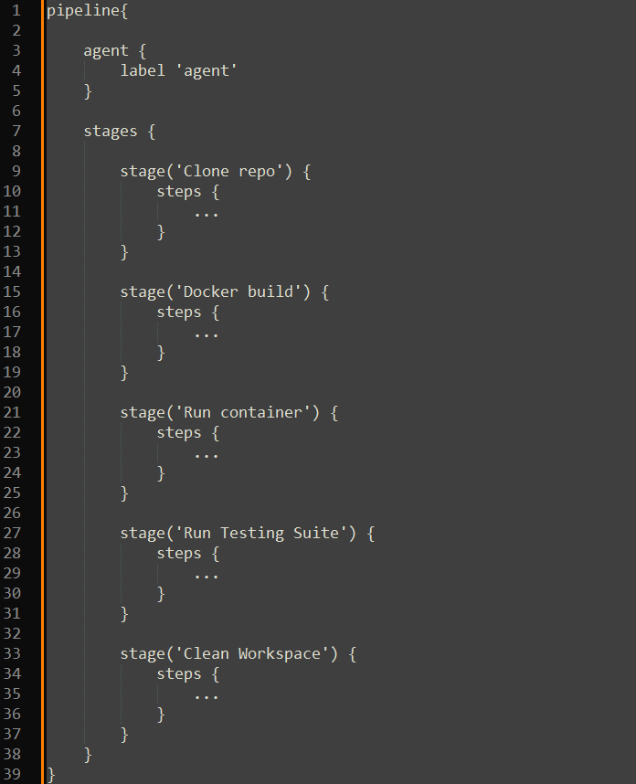

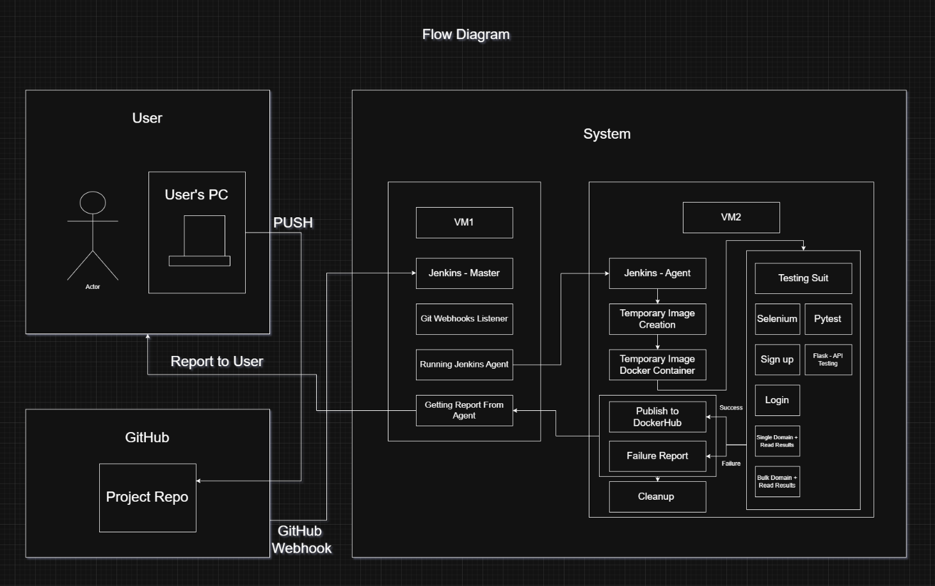
- Flow Diagram

- Prerequisites and Details:
- GitHub Repository: https://github.com/MatanItzhaki12/domain_monitoring_devops.git
- DockerHub Repository:
- AWS Subscription: free tier.
- VM Machines: 2x t3.small (free tier).
- Ports: 8080, 8081, 50000.
- Connections: Internal IP for intra-Jenkins connection.
- Packages: Docker.io, Java.
- Jenkins Image: jenkins/jenkins.
- Services: *.service file for each machine that start Jenkins on startup.

